CBSE CLASS 12 COMPUTER SCIENCE – PYTHON SYLLABUS (2025–26)
Unit I: Computational Thinking and Programming – II
Weightage: 40 Marks
1. Revision of Python (Class 11)
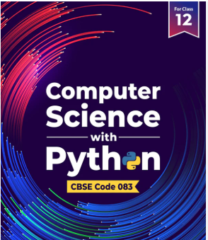
- Python fundamentals: variables, data types, operators
- Conditional statements (if, if-else, elif)
- Loops (for, while)
- Strings, Lists, Tuples, Dictionaries
- Functions and recursion

2. Functions and File Handling
- Defining and calling functions
- Parameters, return values
- Scope of variables (global and local)
- File handling in text files:
  - Reading (read(), readline(), readlines())
  - Writing (write(), writelines())
  - Appending
  - CSV file handling (optional in some schools)

3. Using Python Libraries
- Importing libraries: import, from-import
- Common libraries: math, random

4. Data Structures
- Stack using list:
  - Push, pop, peek operations
- Queue using list:
  - Enqueue, dequeue operations (FIFO)

Unit II: Computer Networks
Weightage: 10 Marks
- Introduction to computer networks
- Types of networks (LAN, MAN, WAN)
- Network devices: Modem, Switch, Router, Hub
- Network topologies: Star, Bus, Ring
- Protocols: TCP/IP, HTTP, FTP, etc.
- Web services: WWW, URL, DNS, IP address
- Cloud computing, cyber safety

Unit III: Database Management
Weightage: 20 Marks
1. Database Concepts
- Introduction to DBMS/RDBMS
- Data models
- Relational data model: tables, rows, columns

2. Structured Query Language (SQL)
- Basic commands: CREATE, INSERT, SELECT, UPDATE, DELETE
- Filtering: WHERE, BETWEEN, IN, LIKE, IS NULL
- Ordering: ORDER BY
- Aggregate functions: COUNT(), SUM(), AVG(), MAX(), MIN()
- Grouping: GROUP BY, HAVING

Unit IV: Society, Law and Ethics
Weightage: 10 Marks
- Digital footprint and identity
- Cybercrime and safety
- Cyber law, plagiarism
- Open source vs proprietary software
- Digital rights and responsibilities

Practicals (30 Marks)
- Python programs (based on file handling, stack/queue)
- SQL queries
- Project (Python + DBMS)
- Viva and notebook

